Exercise 2
Create a new disk of 5GB in the same Windows virtual machine. Now, configure the partitions with GParted to get the following result:

In order to do this we must to create a new disk from storage setting:
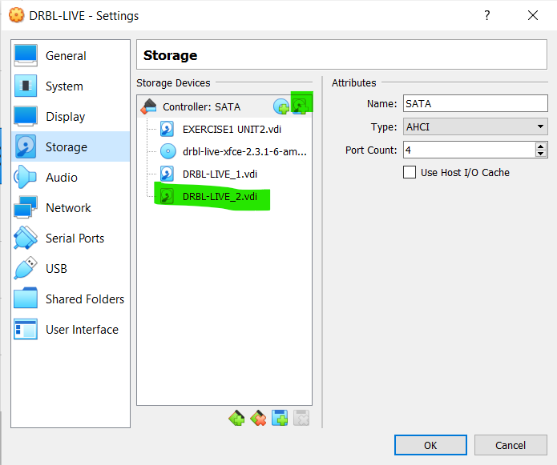
The first thing that we have to do is to create a Gparted form Disk management.
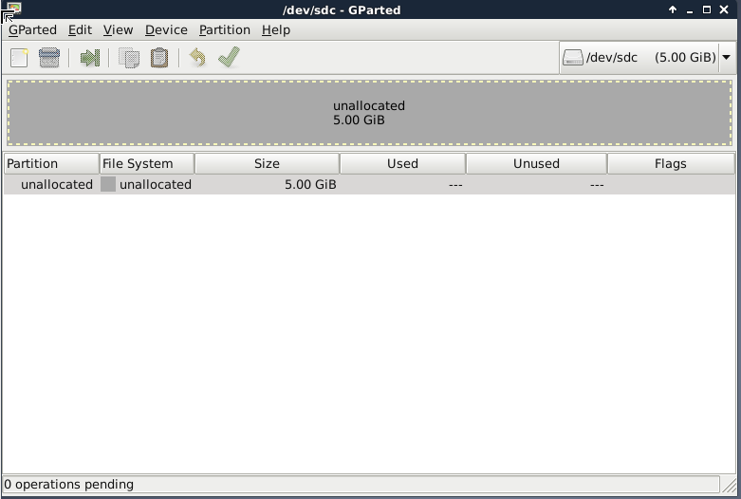
We must to follow the same steps like the previous exercise:
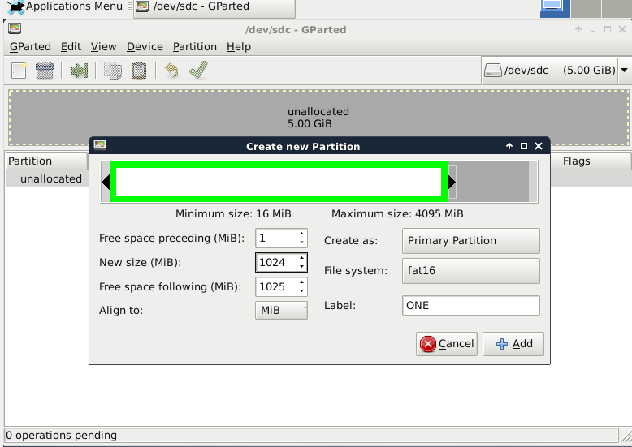

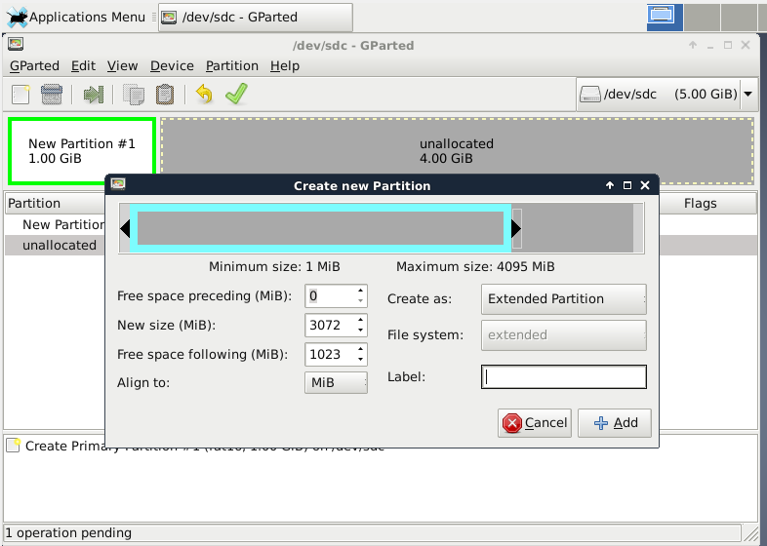

Then we have to create an extended partition in order to match the image of the example:
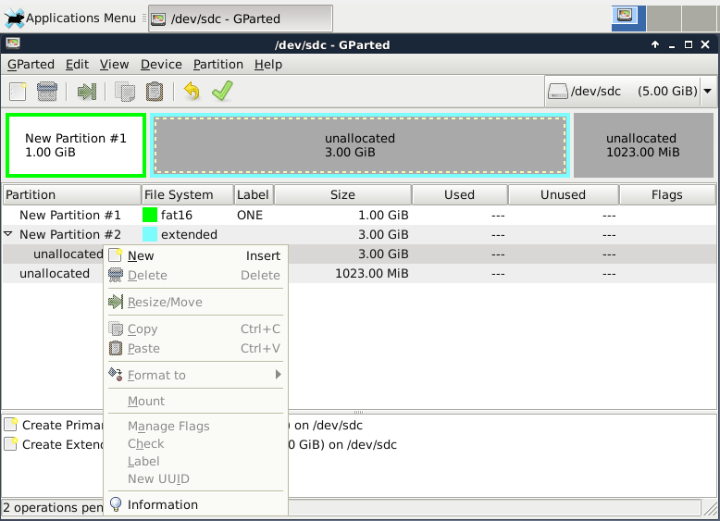
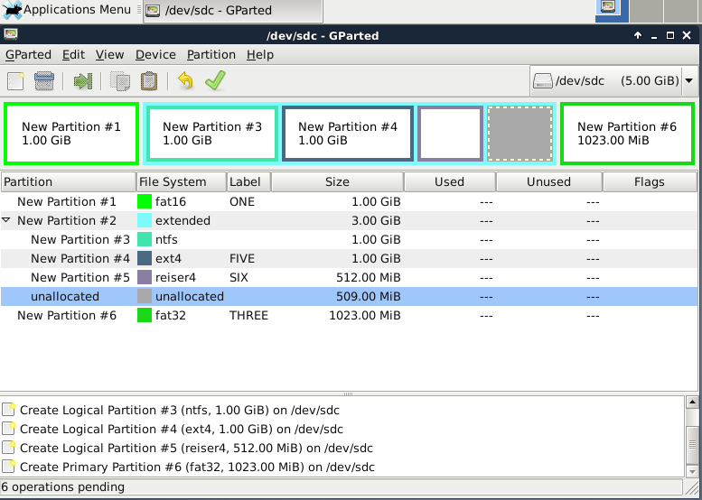

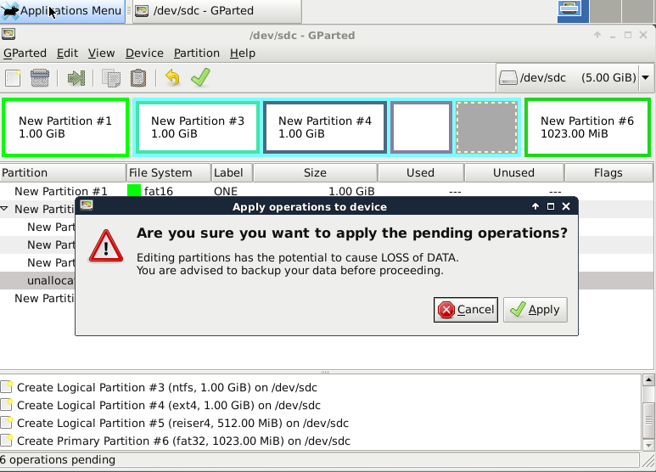
Answer the following questions
- How does GParted name the new hard disk?
/dev/sdc
- List all the partitions you have created, indicating type and file system.
Primary partition with label one, 1024MB, FAT16.
Extended partition of 3072MB: Logical partition with label four, 1024MB, NTFS; Logical partition with label five, 1024MB, ext4 file system; logical partition, label six, 512MB, FAT32.
Primary partition with label three, 1024MB, FAT32.

